THEORY QUESTIONS

SECTION I

THE ENVIRONMENT
1.
Study the vegetation map of Ghana below and use it to answer the questions that follow:
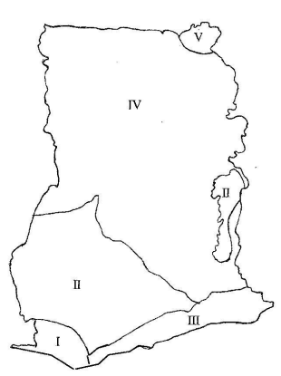
(a)

Identify the vegetation types numbered on the map as follows: I, II, III, IV and V.
(b)

Highlight five benefits of water bodies in Ghana.

2.
(a)

What is cultural change?
(b)

Explain four factors responsible for cultural change in Ghana.

SECTION II

GOVERNMANCE, POLITICS AND STABILITY
3.
(a)

Highlight any four contributions of Ghana to the United Nations Organization.
(b)

In what four ways has Ghana benefited from the United Nations Organization?

4.
(a)

What is separation of powers?
(b)

Outline four advantages of separation of powers.

SECTION III

SOCIAL AND ECONOMIC DEVELOPMENT
5.
In what five ways can Ghana reduce her dependency on foreign financial support?

6.
(a)

Describe four ways through which human resource can be developed in Ghana.
(b)

State two reasons why labour is not fully used in Ghana.

